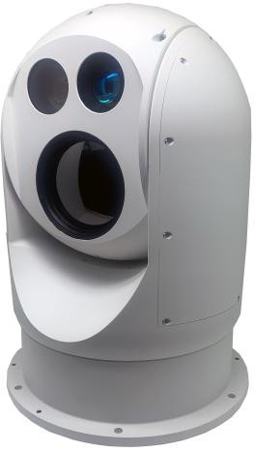

GD-280 Series
GD-280 Series gyro stabilized thermal imaging system is a high-performance monitoring platform that integrates thermal imaging with daylight camera and gyro stabilization functions, and has high protection levels. It can be fixed installing on ground base, vehicle-mounted or shipborne. It can be a stand- alone system or can be integrated into existing networks.

Multisensor
The 1920x1080 pixel high definition daylight camera provides users with clear images during the day. Thermal camera is equipped with uncooled 640x512 detector, it gives you clear crisp image with embedded advance image processing technology. Combined with a 20-100mm continuous zoom lens, it is suitable for use in dark, complex weather conditions and provides clear thermal image for distant targets. At the same time, the equipment is also equipped with 3km laser range finder, which is convenient for users to determine the distance and location of the target.

Waterproofness
The GD-280 housing is strictly waterproof, the mechanical interfaces and cable joints are also strictly waterproof. The GD-280 achieves IP66 protection and can be used all day in complex climates such as salt spray, high humidity and cold.

Pan-Tilt
GD-280 adopts high precision direct drive motor, which makes the equipment rotate more smoothly, positioning more accurate, response more timely. The positioning accuracy is up to 0.005°. Gyro stabilization enables users to obtain clear and stable images under complex ground or water conditions. The precision rotation platform of the GD-280 adopts advanced gyro stabilization technology and has self- stabilization function. The stability is no more than 0.2mrad, which basically eliminates the impact of the vehicle body or the hull shaking on the observation vision, and achieves the purpose of image stability.

Image tracking function(Optional)
Video tracking is based on a powerful video processor with powerful video processing and analysis functions and AI learning capabilities. It can process the video signal, overlay the system status character, and output to the monitor and video recorder through the form of network video stream. Through AI deep learning algorithm, it can realize the function of automatic identification and tracking of various targets. In tracking mode, the platform can automatically turn as the tracked target moves, and the user can select the target to track in the infrared or visible image.
Thermal imaging range performance (100mm lens as an example)
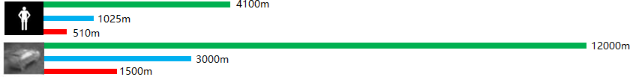

Detection Recognition Identification

Technical Specifications
Model | GD-280 | GD280-T
Thermal Camera
Detector Type | Uncooled LWIR, 640x512 pixel
Spectral Range | 8 -14μm
NETD | ≤40mk @25℃
Rate | 50Hz
Focus Length | 20mm –100mm
FOV | 21.7°x17.5° - 4.4°x3.5°
Daylight Camera
Image Sensor | 1/1.8”CMOS | 1/2” CMOS
Resolution | 1920×1080
Lens (Focus Length) | 6~300mm (50X) | 6~210mm (35X)
FOV | 60.9° ~1.3° | 61.9° ~1.9°
Min Illumination | 0.005Lu /F1.5(Color)；0.0005Lux/F1.5 (B/W)
Laser Rang Finder
Spectral Range | / | 1535nm±5nm
Measuring Rate | / | 1~10Hz (Adjustable)
Accuracy | / | ≤±2m（RMS）
Range | / | ≥3km
Laser illuminator (optional with laser range finder)
Spectral Range | / | 808±5nm
Range | / | 1km/2km
Type | / | Electric synchronous zoom
Pan-Tilt
Az Range | nx360°
El Range | -20° ~ +90°
Maximum angular velocity | 150°/s
Maximum angular acceleration | 150°/s2
Positioning Accuracy | ≤0.005°
Stability Accuracy | ≤0.2mrad
Physical Characteristics
Input Voltage | 27VDC
Consumption | ≤150W
IP Rating | IP66
Material | aluminium alloy
Operating Temperature | -40℃ ~ +60℃
Size | ∅280mm× 430mm
Weight | ＜20Kg

